Practical - 10
Practical Title: Secure Login/Logout with Sessions, Role-Based Access, Timeout, and Remember-Me Token

Problem Definition : Develop secure login and logout functionality using PHP sessions. Verify password using password_verify(), regenerate session ID after login, restrict dashboard access, implement role-based redirection, session timeout, and optional secure remember-me token.

Theory
1. Are sessions started and destroyed securely? Yes, sessions are started using session_start(), the session ID is regenerated after successful login, and session data is destroyed during logout.

2. Is password_verify() used correctly? Yes, password_verify() checks the entered password against the hashed password stored in the database.

3. Is unauthorized dashboard access blocked? Yes, users who are not logged in are redirected to the login page, and role checks restrict access to the appropriate dashboard.

4. Is session timeout implemented? Yes, the session expires after 5 minutes of inactivity and redirects the user to the login page.

5. Are admin and student users redirected to appropriate dashboards? Yes, admin users are redirected to admin.php, while student users are redirected to dashboard.php based on their roles.

A. Evidence of Work (Screenshots):
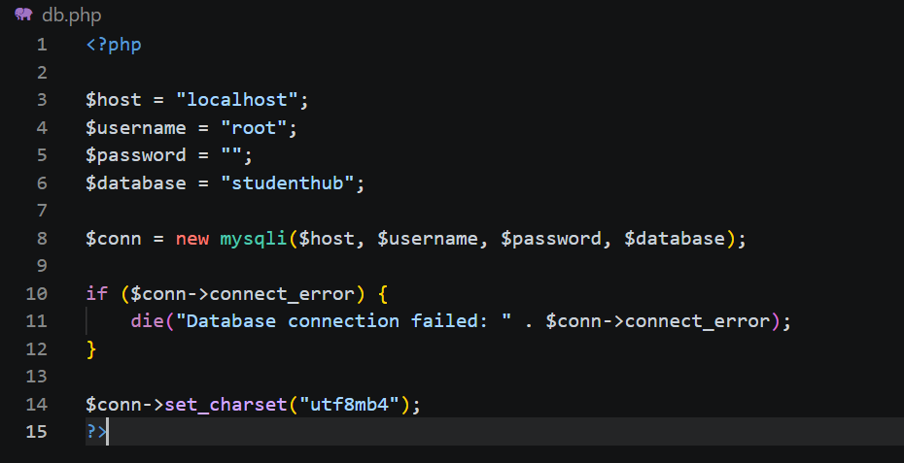
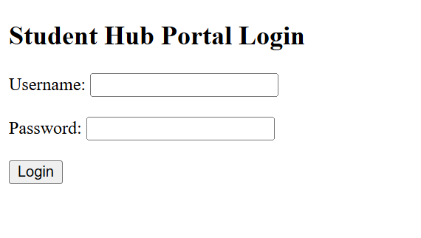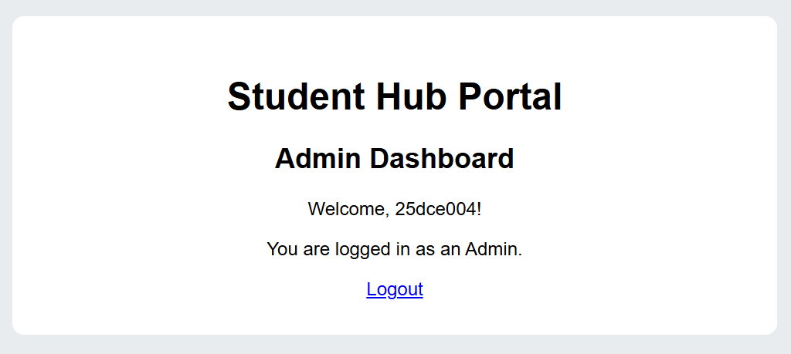
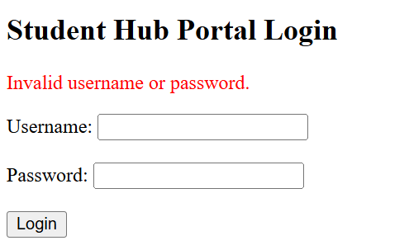
B.GitHub Repository Link:
https://github.com/Andarpadhruvi1125/Student-Hub-portal.git
C.Challenges Faced :
During this practical, I faced challenges in implementing secure login and logout functionality using PHP sessions. I learned how to verify passwords using password_verify(), regenerate session IDs after login, and restrict dashboard access based on user roles. I also faced some difficulty in implementing session timeout and redirecting admin and student users to their respective dashboards.
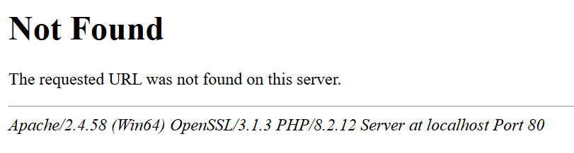
D.Learning Outcomes :
Through this practical, I learned how to implement secure login and logout functionality using PHP sessions. I understood password verification, session management, role-based access control, and session timeout. I also learned how to protect dashboards from unauthorized access and redirect users according to their roles.
Faculty Remarks:

